Drawing Key:

Hambleton Gala

Diversion Route

Diversion Route

February 2020

Ghants Lane

A588

Ghants Lane

Clay Gap Lane

# N

A588

to Knott End

Sower Carr Lane

Moss Lane

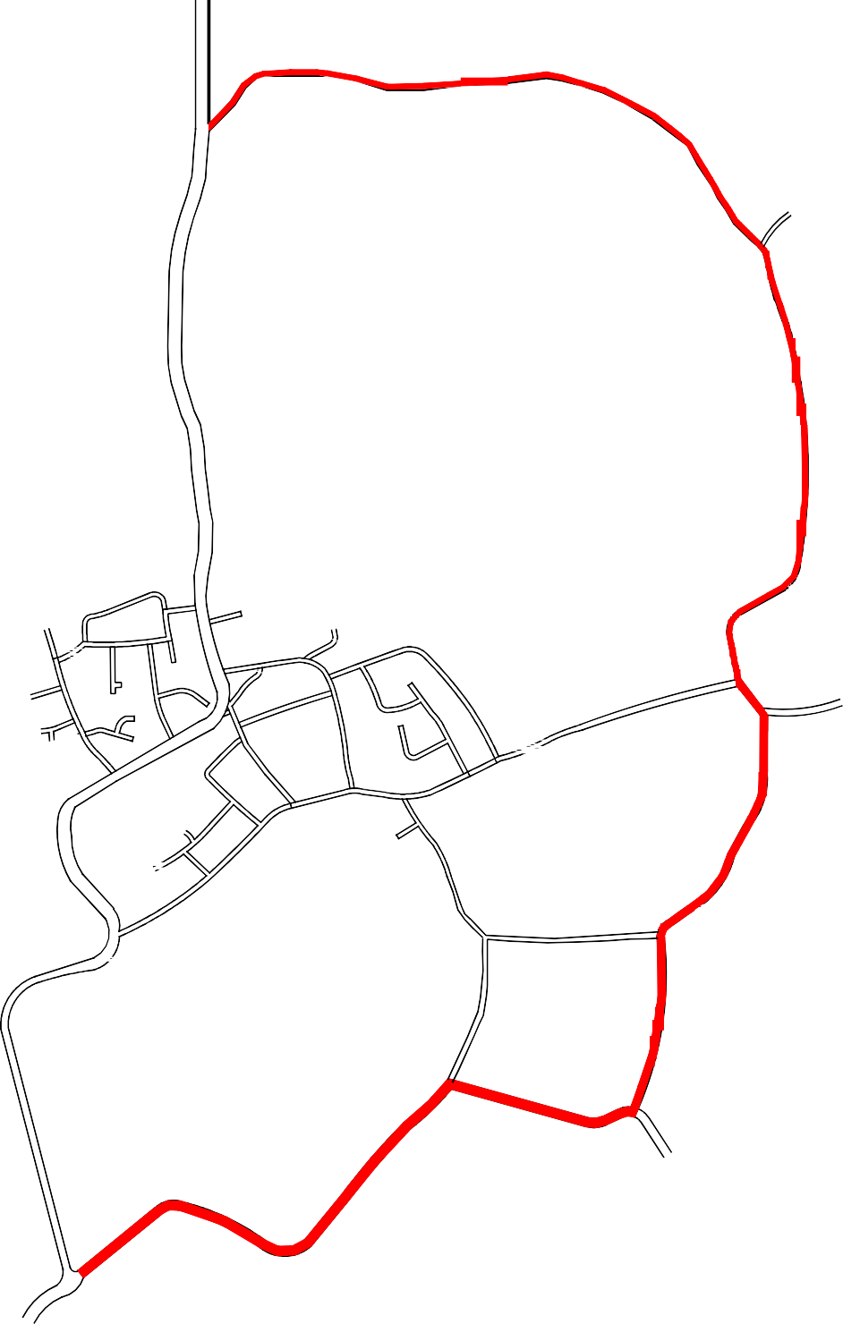

Grange Road

Grange Road

Mill Lane

A588

Marsh Lane

Church Lane

Cutts Lane

# 0 250 500m

Mill Lane

Bull Park Lane

A588

Mill Lane

A588

to Poulton